

**“AZƏRBAYCAN HAVA YOLLARI” CJSC NATIONAL AVIATION ACADEMY**

**Individual Work № 5:**

**Topic:Logarithmic time complexity with examples in python.Binary seach.**

**Subject: Obyektyönümlü proqramlaşdırma**

**Teacher: Mehemmed Shahmaliyev**

**Group: 1459i Student: Hesenova Firuze**

**Date: Signature:H.F**

**Baku 2022**

# **Logarithms and Exponents in Complexity Analysis!**

# **1 - Logarithms 101**

****Logarithms or log:**** A mathematical concept/expression that’s used a lot in Computer Science and it’s the inverse (flip) of exponentials, and they’re used to answer the question: How many times must one “base” number be multiplied by itself to get some other particular number ****or**** (what power you have to raise to, to get another number) ****or**** we can also define it as ****The power**** (or exponent) to which one base number must be raised (multiplied by itself) to produce another number.

****Example****: How many times must a base of 20 be multiplied by itself to get ****8,000****? The answer is ****3**** (****8000***= 20 × 20 × 20***). So the logarithm base 20 of ****8,000**** is ****3****. It’s represented using a subscript (small number) to the lower right of the base number. So the statement would be ****log20(8,000) = 3****.

* ****log20(400)**** is like asking “How many ****20s**** do we multiply to get ****400****? which is 2(20 * 20). So ****log20(400) = 2****

Logarithms are defined using the following equation:

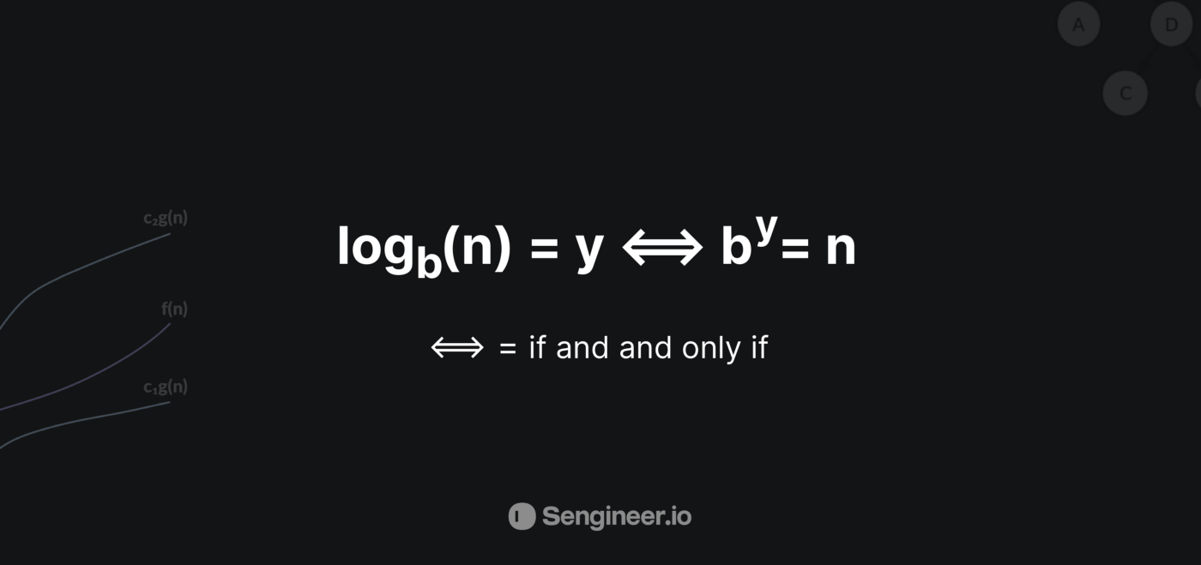

b = base | y = exponent | n = Power (Result obtained by raising b to the power of y)

# **2 - Prerequisites that we need to understand**

* ****Exponent:****A number that identifies how many times that base number or expression must be multiplied by itself, it’s shown as a superscript (tiny number to the upper right of some other “base” number or mathematical expression).
* ****Base****: in a logarithmic statement, a base number is a mathematical object to be multiplied by itself, and it’s expressed as a subscript to the lower right of the base number or by the number of times called for by an exponent, which is written as a superscript to the upper right of that base number
* ****Common logarithm****: A logarithm that has a base number is 10. it’s used in measurements for sound, electricity, and light, etc…
* ****log:****(in math) Abbreviation for logarithm.
* ****Binary logarithm:**** A logarithm where the base number is 2. Binary logarithms are the basis for the binary numeral system, it allows us to count using zero and one numbers only and they’re really important & very common in computer science.

# **3 - Computer science and Binary Logarithms**

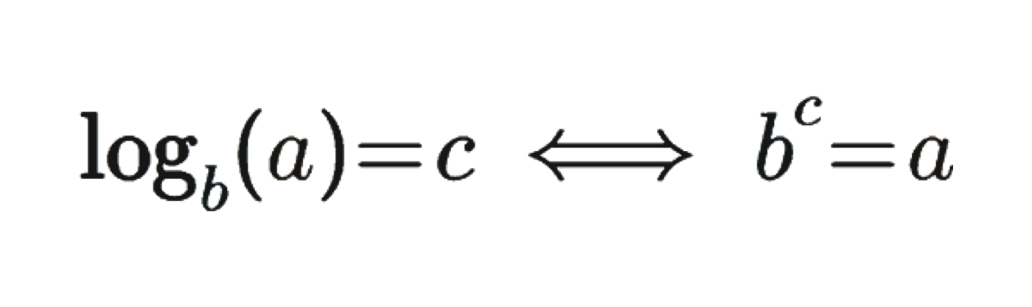

Initially, we have to understand something that may not have been obvious if you’ve seen the expression ***O***(***log n***)**** before with regards to complexity analysis, when we talk about the logarithm, we have to specify a base.

So here the base is “***b****”* and it’s denoted like a little “***b****”* right below the log, and this is very important.

* Because for example if we write log base 5 of number 10, and then we write log base 10 of number 10 we will get very different results because the equation would then be different. the “***b****”* here would either be 5 or 10.

and this is where have to understand/ realize that in computer science and coding interviews when we say log n of we always assume that the base is 2 assume that we’re dealing with what’s called the ****binary logarithm****, which is a logarithm base 2 (as we’ve mentioned in the prerequisites) unless it’s specified to other bases.

# **4 - Why are logarithms in computer science are mostly Binary logarithms?**

Because logarithms mostly occur in computer science by repeatedly dividing some ****data input****(e.g. list, array, etc…)in half, which often occurs with algorithms like:

* divide-and-conquer algorithms like binary search, quicksort, Closest Pair of Points, Merge Sort, etc…

In those cases, the number of times you can divide a ****data input****(e.g. list, array, etc…) of length ****n**** in half before you get down to single-element arrays is log₂ n.

and in computer science, exponential growth usually happens as a consequence of discrete processes like the divide-and-conquer we’ve mentioned. thus, we typically use log2 n as a logarithmic function, since it appears so frequently.

But just to clarify and not to confuse anyone, the fact that we use the binary logarithm most of the time, doesn’t imply that we always only use base 2 logarithms in Computer science. It’s just that it’s just common to work with binary numbers or divide input data in half, which is why base-two logarithms end up being the default in a lot of cases, and in general, ****it really doesn’t matter which base you choose****. Because For example:

* in Big-O notation (Upper bound growth), all logarithms are asymptotically equivalent (the only difference is there multiplicative constant factor);

So we usually don’t even specify the base when writing something like O(log n) because we always assume that the logarithm is the binary logarithm meaning the log base 2, so we don’t even write the base 2 here.

*P.s For those who have math background you’re probably used to using base******10******when you say log of N which is used in math typically.*

*if you’re used to this remember that for the purpose of computer science and coding interviews, you’re mostly always gonna be dealing with log base 2 unless it’s specified otherwise.*

# **5 - The relation and what it means in terms of complexity analysis**

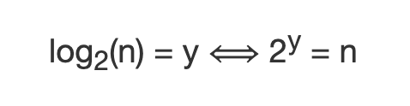

As we’ve mentioned before it basically means that log(n) is the power to which you need to put 2 to get “***n”***.

*****So logarithm base 2 of n would be equal to y if and only if the number 2 to the power of y were equal to n.*****

* For instance, this means that 1 is equal to the power that we need to put 2 to get one. and that power is 0. ***log***(***1***)***= 0***because 2 to the power of 0 is equal to 1: ****log(1) = 0 , 2⁰ = 1****, other examples:
* The log of 8 would be: ***log***(***8***)***= 3, 2³ = 8***
* The log of 16 would be: ***log***(***16***)***= 4, 2⁴ = 16***

so to find the logarithm or ****the binary logarithm**** We have to ask ourselves, 2 to the power of what is equal to that number? And if we solve this then we find ***log*** ***n***.

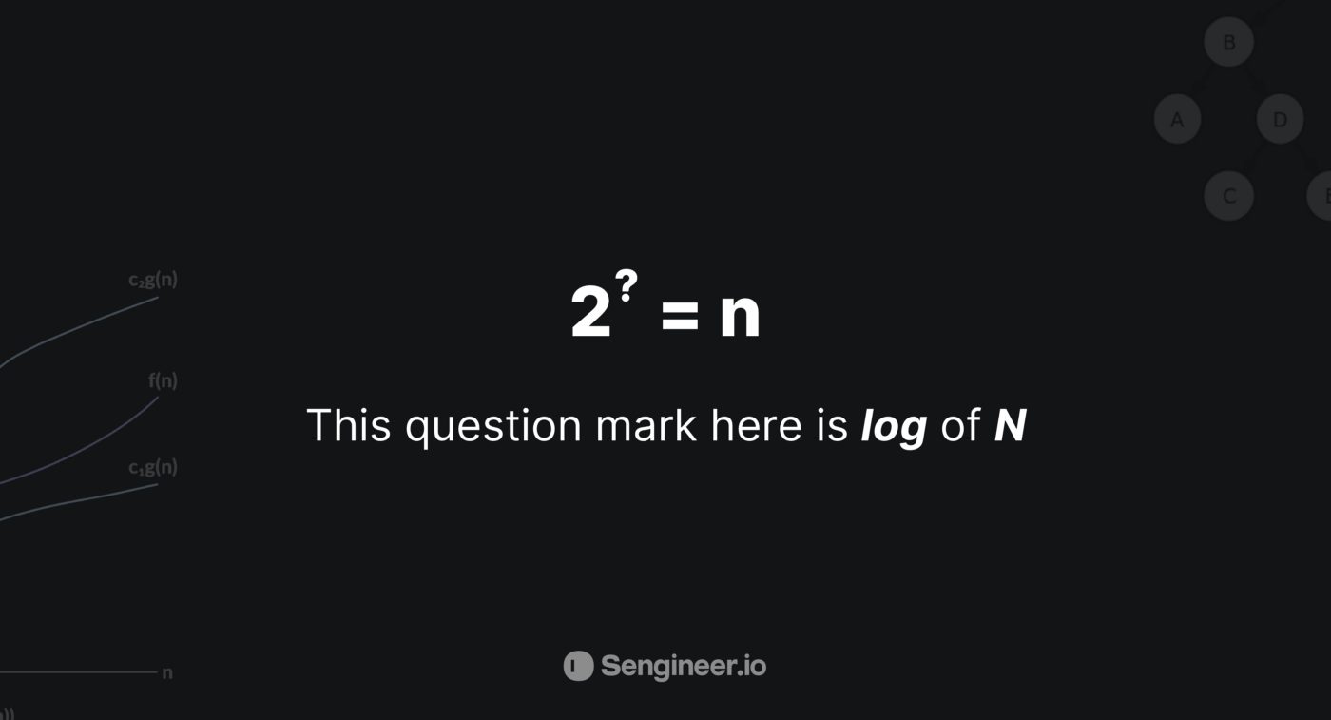

So what does this mean?

Let’s look at powers of two, When we increase a power of two, what we’re really doing is that we’re doubling whatever number we previously had, right?!

If we have the number ***2*** to the power of ***x***, and we do ****2****to the power of****(x+1)****, we are multiplying that number by 2 or doubling it, right?

* ****Example****: ***2⁷ = 2⁶***· ***2*** Two to the power 7 is 64. 64 multiplied by two is 128, which is ****2**** to the power of ****7****. So, whenever we increase the exponent in two to the power of something by one, We are doubling that number. That’s really important.

In other words, when we double the number ***N***, We are only increasing this question mark by one. So easy right!

* ****Example #2:****let’s suppose that we have ****2⁴ = 16****, and now you double 16, which is the number N here in the picture above, we double 16 to 32, and all we have to do is increase the exponent by one ****2⁵ = 32****

****Recap****: So as we can see in this relation picture, 2 to the power of question mark equals ***N***. As ***N*** doubles the question mark only increases by one. Even when ***N*** is very big. And we can see this more clearly if we tried to increase the exponents by a bit more. For instance, if we write out 2 to the power of 20. E.g.

* ****2³⁰ =1,073,741,824**** | ****2⁴⁰ = 1,099,511,627,776****We increased the exponent only by 10.

So the purpose behind showing all of these examples is that the more N increases, the exponent or the question mark that is in the picture increases by a tiny amount, and since this relation, ****2**** to the power of ****?**** equals ***N***, is equivalent to ***log(n)*** ****=**** ****?****, and this tells us what *log(n)*really represents!

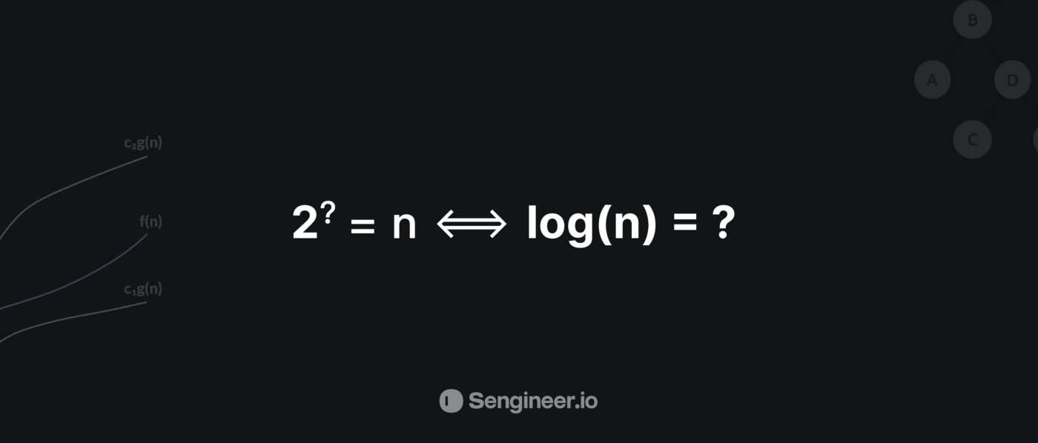

***log(n)*** increases only by a tiny amount as ****N**** increases. When ****N**** doubles, ***log(n)*** only increases by 1. And so this is why, if we tie this back to complexity analysis when we have an algorithm with time complexity of *log(n)*, that is incredibly good because that means as the input increases/doubles, the number of elementary operations that we’re performing in the algorithm only increases by one.

*****Logarithmic time complexity*******log(n)***: Represented in Big O notation as******O(log n)******, when an algorithm has O(log n) running time, it means that as the input size grows, the number of operations grows very slowly.******Example:******binary search.*

So I think now it’s clear for you that a ***log(n)*** complexity is extremely better than a ****linear complexity O(n)****. Even though ****O(n)****, linear time is already pretty good for an algorithm. ***log(n)*** time is gonna be way better as the size of your input increases.

# **6 - Comparing the logarithmic function vs. the linear function on the asymptote graph**

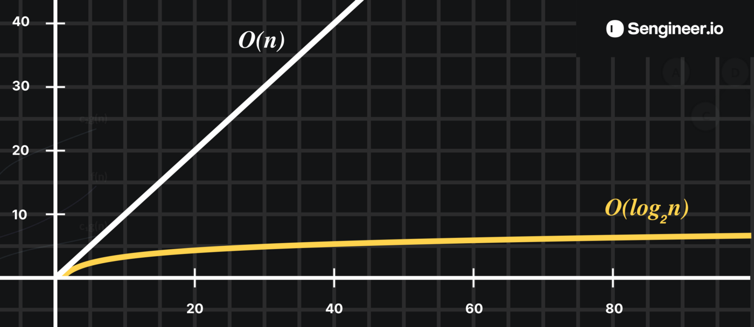

if you’re familiar with the Big-O Complexity Chart you can see that the x-axis is here represents the number ****N****.

a linear function complexity would look something like the ***O(n)***, where the complexity increase linearly with ****N****.

* So when ****N**** is equal to let's say a billion. This line is gonna be at a billion;
* Whereas the O(log n) function, as you see in the asymptotic graph It goes up at the very beginning, as we’ve mentioned earlier that ****log(1) = 0 —**** ****log(4) = 2 —**** ****log(8) = 3****.
* so it increases modestly at first, But then here the more the input gets bigger, (the more N increases) the less the log(n) function changes. Like we said up here when N is a million log(n) will only be 20.
* Even when N is gonna be a billion, log(n) is still only gonna be 30. It will have only increased by 20.

and that’s why log(n)is so powerful because the complexity of log(n) really represents a complexity that does not increase fast as the size of the input increases.

# ****7 - The Final golden example: Binary search ✨****

*P.s Binary search only can work only with sorted (Lists, Array, etc…)*

****Binary search**** is an efficient Interval Searching algorithm that can search sorted lists for the desired target.

Example:

* let’s suppose that we have a list of ****1,024**** elements and I have a number in mind that you have to guess in the fewest tries possible
* And with every guess, you get to know, if your guess was too high, too low, or correct.

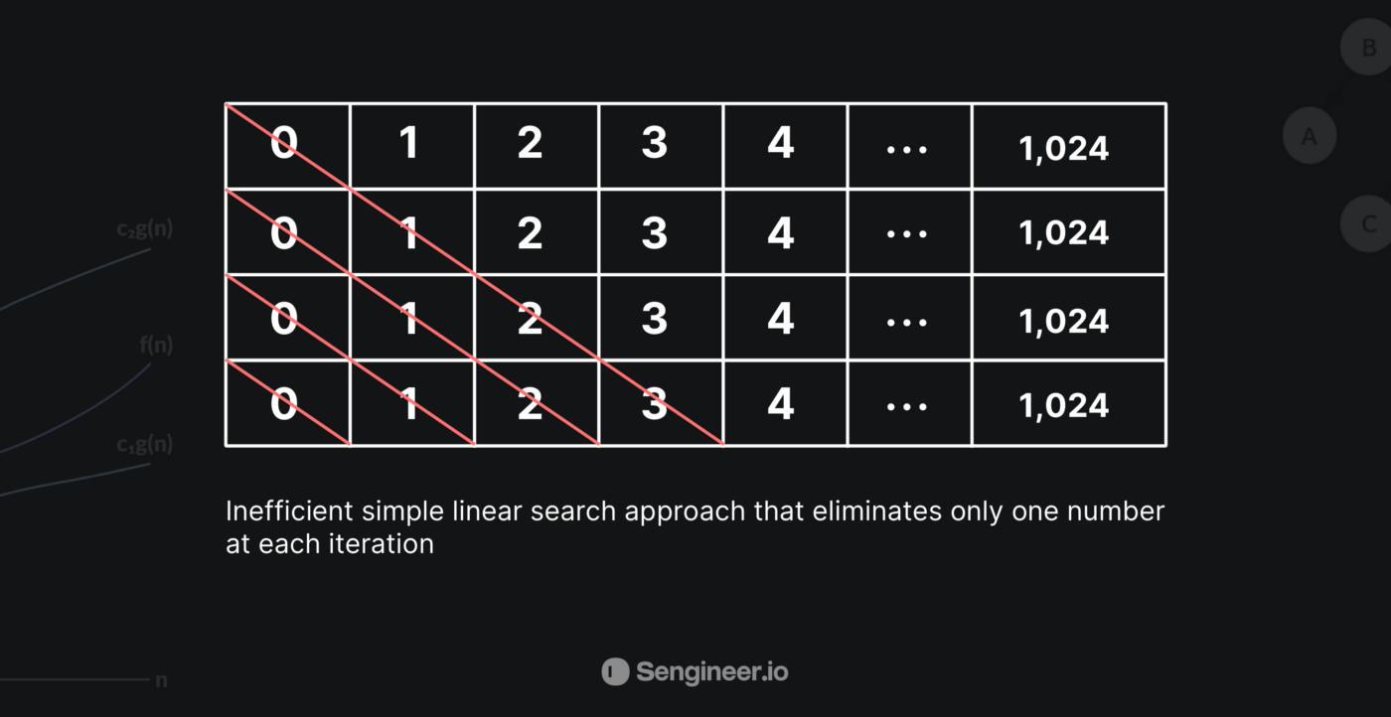

* One approach you can use is to start guessing in a linear manner like saying: is it 0, if it was too low you will say 1, again if it was too low, you will say 2 and so on, and this approach is known as linear approach and based on what we know until now about the differences between the linear and the logarithmic time we can do better right?!

Now the other (better) approach and instead of starting with the first element how about we start with the middle element, and if it was too low then, in that case, we eliminated half of the input right?!

* So now after our guess was lower than the dried number and because we know that 0 until 512 are all lower than the number we want to guess, our next guess would be following the same approach, we half what’s left from the search space, and in that case, our second guess will be ****768****
* ****768****was too high, but what happened again is that we cut down half of what’s left from the numbers in the search space

And this is how Binary search works It starts searching for the desired element in the middle of the input(Array, List, etc..), and then it moves to the right or left and depending on if the value you are looking for is bigger or smaller, and as we saw it reduces half of the remaining numbers in the search space at each iteration.

* So now in this case our next guess would be between ****512**** and ****768****
* So now instead of the ****1,024****linear operations, we’ve seen in the case of linear search, it will take a max of ****10**** steps to get to the desired value we want with the Binary Search that has a logarithmic time complexity
* Another example: Let’s suppose that we’re looking for the desired value in a ****1,073,741,824**** items list, if we want to search for the value we want and it was at the end of the list, if we want to use the linear approach then we have to iterate ****1,073,741,824 n times****to get to the desired value. on the other hand, if we want to do this in a ****logarithmic**** fashion using binary search it would take us a max of ****log₂n**** ****30**** ****guesses,****Mind-blowing right!

So now that we’ve got to know how binary search works, let’s see a code example, to solidify our understanding of the algorithm:

***const binarySearch = (list, target) => {***

***let leftPointer = 0; // the beggining of the list***

***let rightPointer = list.length - 1; // the end of the list***

***/\****

***When leftPointer is bigger than rightPointer it means that***

***the target we were looking for doesn't exist in the array so we return []***

***\*/***

***while (leftPointer < rightPointer) {***

***// Rounding down the middle pointer cause our input might not be perfect and we can't have decimal indexes***

***let middlePointer = Math.floor((leftPointer + rightPointer) / 2)***

***let guess = list[middlePointer];***

***if (guess === target) { // Checking if the target we were looking for was present in the first iteration (Middle element)***

***return middlePointer // if we found the item we return it***

***}***

***if (guess > target) { // The guess was too high***

***/\****

***If the guess was too low or too high update the pointer accordingly,***

***which will reduce half the input in each iteration O(log₂n)***

***\*/***

***rightPointer = middlePointer--***

***} else { // The guess was too low***

***leftPointer = middlePointer++***

***}***

***}***

***return []***

***}***

***console.log(binarySearch([1, 2, 3, 4, 5, 6, 7, 8, 9, 10, 11, 12, 13, 14, 15], 1))***

when we have an algorithm that divides the data in half on each call, we are most likely dealing with logarithmic runtime: O(log n).

**Binary Search**

Problem: Given a sorted array arr[] of n elements, write a function to search a given element x in arr[].

Examples:



**Linear Search Approach:** A simple approach is to do a [linear search](https://www.geeksforgeeks.org/linear-search/). The time complexity of the Linear search is O(n). Another approach to perform the same task is using Binary Search.

**Binary Search Approach:**

*Binary Search is a [searching algorithm](https://www.geeksforgeeks.org/searching-algorithms/) used in a sorted array by repeatedly dividing the search interval in half. The idea of binary search is to use the information that the array is sorted and reduce the time complexity to O(Log n).*

**Binary Search Algorithm:** The basic steps to perform Binary Search are:

* Begin with an interval covering the whole array.
* If the value of the search key is less than the item in the middle of the interval, narrow the interval to the lower half.
* Otherwise, narrow it to the upper half.
* Repeatedly check until the value is found or the interval is empty.

**Illustration of Binary Search Algorithm:**

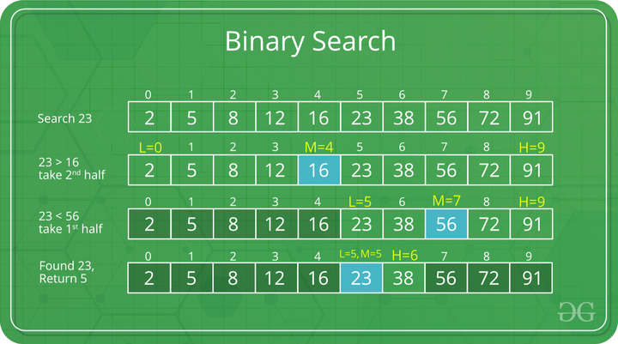

Step-by-step Binary Search Algorithm: We basically ignore half of the elements just after one comparison.

* Compare x with the middle element.
* If x matches with the middle element, we return the mid index.
* Else If x is greater than the mid element, then x can only lie in the right half subarray after the mid element. So we recur for the right half.
* Else (x is smaller) recur for the left half.

**Recursive implementation of Binary Search:**

***# Python3 Program for recursive binary search.***

***# Returns index of x in arr if present, else -1***

***def binarySearch(arr, l, r, x):***

***# Check base case***

***if r >= l:***

***mid = l + (r - l) // 2***

***# If element is present at the middle itself***

***if arr[mid] == x:***

***return mid***

***# If element is smaller than mid, then it***

***# can only be present in left subarray***

***elif arr[mid] > x:***

***return binarySearch(arr, l, mid-1, x)***

***# Else the element can only be present***

***# in right subarray***

***else:***

***return binarySearch(arr, mid + 1, r, x)***

***else:***

***# Element is not present in the array***

***return -1***

***# Driver Code***

***arr = [2, 3, 4, 10, 40]***

***x = 10***

***# Function call***

***result = binarySearch(arr, 0, len(arr)-1, x)***

***if result != -1:***

***print("Element is present at index % d" % result)***

***else:***

***print("Element is not present in array")***

**Output**

***Element is present at index 3***

**Iterative implementation of Binary Search**

***# Python3 code to implement iterative Binary***

***# Search.***

***# It returns location of x in given array arr***

***# if present, else returns -1***

***def binarySearch(arr, l, r, x):***

***while l <= r:***

***mid = l + (r - l) // 2***

***# Check if x is present at mid***

***if arr[mid] == x:***

***return mid***

***# If x is greater, ignore left half***

***elif arr[mid] < x:***

***l = mid + 1***

***# If x is smaller, ignore right half***

***else:***

***r = mid - 1***

***# If we reach here, then the element***

***# was not present***

***return -1***

***# Driver Code***

***arr = [2, 3, 4, 10, 40]***

***x = 10***

***# Function call***

***result = binarySearch(arr, 0, len(arr)-1, x)***

***if result != -1:***

***print("Element is present at index % d" % result)***

***else:***

***print("Element is not present in array")***

**Output**

***Element is present at index 3***

Algorithmic Paradigm: [Decrease and Conquer](https://www.geeksforgeeks.org/decrease-and-conquer/).

Note: Here we are using

*int mid = low + (high – low)/2;*

Maybe, you wonder why we are calculating the middle index this way, we can simply add the lower and higher index and divide it by 2.

*int mid = (low + high)/2;*

But if we calculate the middle index like this means our code is not 100% correct, it contains bugs.

That is, it fails for larger values of int variables low and high. Specifically, it fails if the sum of low and high is greater than the maximum positive int value($2^{31}$ – 1 ).

The sum overflows to a negative value and the value stays negative when divided by 2.   
In java, it throws ArrayIndexOutOfBoundException.

*int mid = low + (high – low)/2;*

So it’s better to use it like this. This bug applies equally to merge sort and other divide and conquer algorithms.